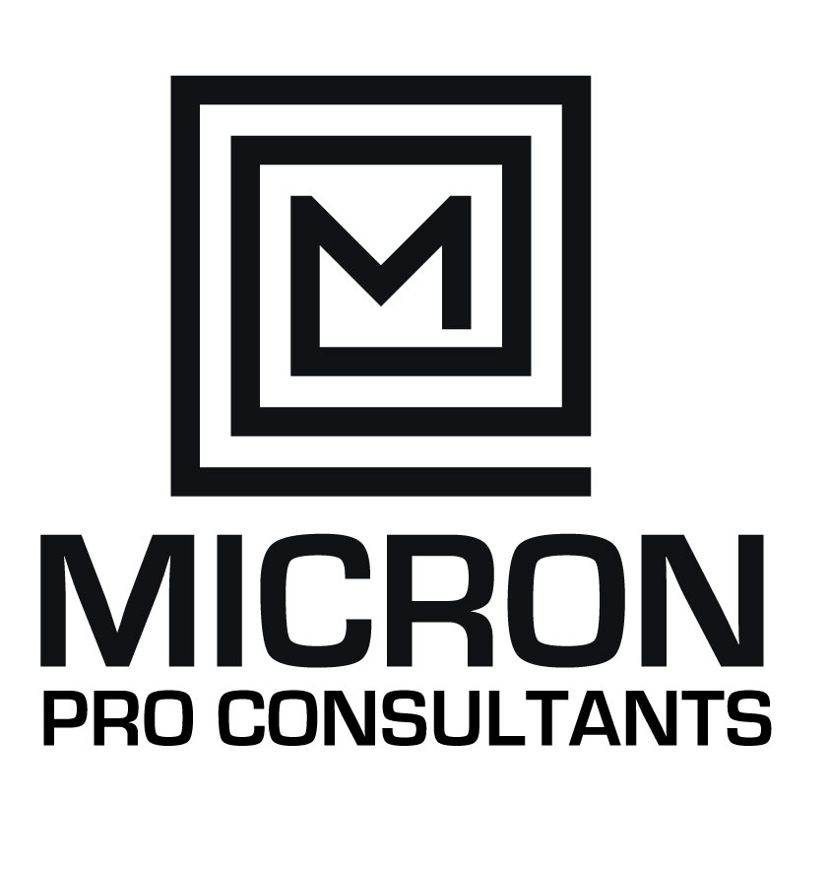

**Company Overview 3**

**About Us 3**

**Core Values: 5**

**OUR APPROACH 6**

**Personalized Attention 6**

**Open Communication 6**

**Supportive Environment 6**

**Empowerment and Growth 6**

**Ongoing Partnership 6**

**Genuine Care 6**

**Meet Our Team Leader 8**

**CEO –Michele Scott, MSc 8**

**Our Services 9**

**Clientele 11**

**Contact Us! 13**

# Company Overview

**Name:** MICRO PRO CONSULTANTS LIMITED

**Location:** 6 Tremaine Mews Kingston 6

**Founded:** Registered in 2017

**Type:** Limited Liability Company registered with the Companies Offices of Jamaica

**Industry:** Business Sector

**Executive Summary**

**Company Information:**

Name: MICRO PRO CONSULTANTS LIMITED

Location: 22B Old Hope Road, Kingston 5

Founded: Registered in 2017

Type: Limited Liability Company registered with the Companies Offices of Jamaica

**MICRON Pro Consultants** is a premier business coaching and consulting firm based in Jamaica, dedicated to empowering business leaders and entrepreneurs to reach their highest potential. With services tailored to drive growth, enhance leadership skills, and optimize business operations, we aim to transform businesses and inspire enduring success.

**MICRON Pro Consultants** is committed to empowering business leaders and entrepreneurs to achieve their highest potential. Founded on the principles of trust, innovation, and excellence, we offer a wide range of services designed to facilitate growth, enhance leadership skills, and optimize business operations.

**Mission:**

We intend to empower business leaders with knowledge, strategies, and confidence to maximize their true potential in business, improve the lives of their families, staff and community ultimately producing significant returns engendering nation building.

**Vision:**

**We are committed to** being one of the leading catalyst for business transformation and growth in Jamaica and the Caribbean by creating a global community of thriving businesses guided by empowered, confident leaders.

**Core Services:**

Business Coaching, Leadership Planning & Development, Strategic Planning and Management, Project Planning & Management, Business Planning & Development, Estate Planning & Management, Marketing & Branding Planning, Corporate & Operational Planning and Efficiency Management, Sales Planning and Training, Strategic Change Planning & Management, Team Building and Personal Development Workshops, Customer Relationship Planning & Management (CRM).

**Company Description**

**Micron Pro Consultants** is a consulting firm which was founded on the principles of trust, innovation, and excellence. We provide a comprehensive range of services designed to address the unique needs of each client, from small and medium-sized enterprises (SMEs) to large organizations.

# About Us

**Our Services:**

We offer a wide range of services tailored to meet the unique needs of each client:

Services are short and long term. For example, a client may only engage us to do their plans as opposed to the implementation management of the process (Short & Long Term). They are as follows;

* Business Coaching
* Leadership Planning & Development
* Strategic Planning and Management
* Project Planning & Management
* Business Planning & Development
* Estate Planning & Management
* Marketing & Branding Planning
* Corporate & Operational Planning and Efficiency Management
* Sales Planning and Training
* Strategic Change Planning & Management
* Team Building, Personal Development Workshops
* Customer Relationship Planning & Management (CRM)

**Why Choose Us?**

1. **Personalized Attention:** We tailor our coaching and consulting services to your specific needs and goals.
2. **Expertise:** Our team of experienced coaches and consultants brings a wealth of knowledge and industry insights.
3. **Supportive Environment:** We create a safe space for you to explore new ideas and strategies.
4. **Commitment to Excellence:** We are dedicated to delivering the highest quality services and achieving exceptional results.
5. **Ongoing Partnership:** We are with you every step of the way, providing continuous support and guidance.

At Micron Pro Consultants, our clients are at the heart of everything we do. We believe in fostering strong, meaningful relationships built on trust, respect, and genuine care. Here's how we ensure every interaction is a positive and empowering experience:

# Core Values:

* **Integrity:** We conduct our business with the highest ethical standards.
* **Innovation:** We embrace creativity and seek out new, innovative solutions.
* **Excellence:** We are committed to delivering exceptional quality in everything we do.
* **Collaboration:** We believe in the power of teamwork and partnership

# OUR APPROACH

At MICRON PRO CONSULTANTS, we are more than just business coaches, and consultants but project managers. We are your dedicated partners in success, committed to helping you achieve your business goals and unlock your full potential. Let's create a thriving future together.

### **Personalized Attention**

We understand that each business is unique, with its own set of challenges and goals. That's why we take the time to truly get to know you and your business. By understanding your specific needs, aspirations, and concerns, we tailor our coaching approach to provide the most relevant and impactful guidance.

### **Open Communication**

We believe in maintaining open, honest, and transparent communication. Our clients are encouraged to share their thoughts, ideas, and feedback freely. We listen actively and provide constructive, thoughtful responses, ensuring you always feel heard and valued.

### **Supportive Environment**

Our goal is to create a safe, supportive environment where you can explore new ideas and strategies without fear of judgment. We celebrate your successes with you and stand by your side through challenges, offering encouragement and solutions to help you overcome obstacles.

### **Empowerment and Growth**

We are committed to empowering our clients with the knowledge, skills, and confidence they need to achieve their business goals. Our coaching sessions are designed to inspire and motivate, helping you unlock your full potential and drive your business forward.

### **Ongoing Partnership**

Our relationship doesn't end with a single coaching session. We see ourselves as long-term partners in your business journey. We provide continuous support, follow-up, and resources to ensure you stay on track and continue to grow and thrive.

### **Genuine Care**

Above all, we genuinely care about your success and well-being. We are passionate about helping you achieve your dreams and are dedicated to seeing you succeed. Your triumphs are our triumphs, and your challenges are our challenges. Together, we can create a brighter future for your business.

### 

# Meet Our Team Leader

### **CEO –Michele Scott, MSc**

Michele Scott is an insightful and intuitive business coach and consultant with an impressive academic and professional pedigree. Graduating Summa Cum Laude from Shaw University with a BA in Sociology and Business Management, and earning a Master's in Government Public Sector Management from the University of the West Indies, Michele combines deep sociological insights with strategic business acumen.

Michele’s strengths are in

* **Project Management:** Leading projects of all sizes to 10x success with timely and efficient delivery.
* **Marketing Strategy:** Crafting and executing dynamic marketing strategies to maximize brand visibility and drive exponential growth.
* **Communication:** Delivering clear, compelling messages that resonate with and engage diverse audiences.
* **Strategic Planning:** Developing and implementing purposed, game-changing strategic plans that align with organizational goals for sustainable success.
* **Operational Planning:** Streamlining operations to boost efficiency, productivity, and overall performance.

Michele's career spans both public and private sectors, where she has consistently driven growth, innovation, and excellence for SMEs and large organizations alike. Her unique blend of sociological insight and business strategy makes her an invaluable asset to any organization.

Committed to continuous learning and excellence, Michele empowers her clients to navigate challenges, seize opportunities, and achieve their business aspirations. Partnering with Michele Scott means unlocking your growth potential and building a thriving future.

# Our Services

**Business Coaching**

* + Tailored coaching sessions to help you navigate challenges, set and achieve goals, and maximize your business potential. For Start ups, SMEs, Large Organizations

**Leadership Development**

* + Training programs to enhance your leadership skills, improve team management, and foster a positive workplace culture.

**Strategic Planning**

* + Comprehensive planning services to develop and implement effective business strategies for sustainable growth.

**Project Management**

* + Expert project management to ensure your projects are completed on time, within budget, and to the highest standards.

**Marketing, Digital Marketing and Branding**

* + Customized marketing and branding strategies to increase your business's visibility, attract your target audience, and build a strong brand identity.
  + Company Profiles, Personal Profiles (including resumes and CVs),
* **Business Development**
  + Strategies and initiatives to identify new market opportunities, build strategic partnerships, and drive business growth.

**Operational Efficiency**

* + Process optimization and efficiency improvement to streamline your operations and boost productivity.

**Sales Training**

* + Sales coaching and training to enhance your sales team's performance and increase revenue.

**Change Management**

* + Support and guidance through organizational changes to ensure smooth transitions and minimize disruptions.

**Team Building**

* + Activities and workshops designed to strengthen team cohesion, communication, and collaboration.

**Customer Relationship Management (CRM)**

* + Strategies and tools to improve customer relations, retention, and satisfaction.

**Innovation and Growth Workshops**

* + Interactive workshops focused on fostering innovation and identifying new growth opportunities.

# Clientele:

MICRON PRO CONSULTANTS serves a diverse range of clients, from ambitious entrepreneurs and small business owners to established leaders and executives in larger organizations. Our clients include:

**Startups and Entrepreneurs:**

* + Individuals launching new ventures or looking to scale their startups.
  + Focus on foundational strategies, business planning, and growth acceleration.

**Small and Medium-Sized Enterprises (SMEs):**

* + Businesses seeking to optimize operations, improve efficiency, and drive sustainable growth.
  + Emphasis on strategic planning, marketing, and operational efficiency.

**Corporate Leaders and Executives:**

* + Senior leaders and executives aiming to enhance leadership skills and organizational performance.
  + Specialized coaching in leadership development, change management, and team building.

**Public Sector Organizations:**

* + Government agencies and public sector entities seeking to improve efficiency and service delivery.
  + Expertise in project management, strategic planning, and public sector management.

**Non-Profit Organizations:**

* + Non-profits aiming to maximize impact, improve fundraising, and enhance operational efficiency.
  + Guidance in strategic planning, marketing, and stakeholder engagement.

**Market Overview:**

Our market is dynamic and diverse, encompassing various sectors and industries. Key market characteristics include:

1. **Growing Demand for Business Coaching:**
   * Increased recognition of the value of business coaching in achieving organizational goals and personal growth.
   * Demand driven by the need for professional development, strategic guidance, and operational optimization.
2. **Diverse Industry Representation:**
   * Clients from a wide range of industries, including technology, healthcare, finance, retail, manufacturing, and more.
   * Each industry presents unique challenges and opportunities, requiring tailored approaches and solutions.
3. **Focus on Innovation and Adaptability:**
   * Businesses are increasingly seeking innovative strategies to stay competitive in a rapidly changing market.
   * Emphasis on adaptability, continuous improvement, and leveraging new technologies.
4. **Global Reach:**
   * While our primary market may be regional or national, there is growing interest from international clients seeking high-quality coaching and consulting services.
   * Ability to support remote and virtual engagements, expanding our global footprint.
5. **Public and Private Sector Engagement:**
   * Extensive experience in both public and private sectors, allowing us to understand and address the unique needs and challenges of each.
   * Public sector clients benefit from our expertise in government and public sector management, while private sector clients leverage our business acumen and strategic insights.

**Why Choose Us:**

Our clients choose [Your Company Name] because of our proven track record of delivering impactful, practical, and customized solutions. We are committed to their success, offering a holistic approach that addresses all aspects of their business and leadership needs. With a focus on integrity, excellence, and continuous support, we empower our clients to achieve their highest potential and drive lasting success.

# Contact Us!

In Jamaica, several firms and individuals offer business coaching and consulting services that could be considered competitors to Michele Scott and Micron Pro Consultants. Here are some notable ones:

1. **Deloitte Jamaica**
   * Provides comprehensive consulting services, including strategic planning, financial consulting, and operational efficiency, catering to various industries.
2. **PwC Jamaica**
   * Offers a wide range of advisory services, including business development, financial consulting, and strategic planning, with a strong local presence.
3. **Ernst & Young (EY) Jamaica**
   * Delivers business advisory services focused on strategy, operations, and business transformation, leveraging global expertise with local insights.
4. **KPMG Jamaica**
   * Provides consulting services across strategic planning, business development, and risk management, known for their thorough approach and extensive industry experience.
5. **MC Systems**
   * A leading technology consulting firm in Jamaica, offering services in business process optimization, digital transformation, and strategic IT planning.
6. **Caribbean HR Solutions**
   * Specializes in human resource consulting, including leadership development, team building, and strategic HR planning, catering to various business sectors.
7. **Synergy West Solutions**
   * Offers business consulting services focused on project management, strategic planning, and operational efficiency, known for their client-centric approach.
8. **Excel Management & Consulting Services**
   * Provides a range of consulting services, including business coaching, marketing strategy, and operational planning, with a focus on SMEs.
9. **Jamaica Business Development Corporation (JBDC)**
   * Offers support and advisory services to entrepreneurs and SMEs, including business coaching, financial consulting, and market access services.
10. **Corporate Dynamics Limited**
    * Specializes in leadership development, team building, and organizational development, helping businesses achieve sustainable growth.
11. **Business Development Consultants Ltd.**
    * Provides strategic planning, project management, and business development services, focusing on driving innovation and excellence.
12. **DPM International**
    * Offers comprehensive consulting services, including financial planning, business strategy, and market analysis, serving both local and international clients.
13. **Impact Training & Development Services**
    * Focuses on leadership development, sales training, and team building, providing customized training programs to enhance business performance.
14. **Blue Chip Consultants**
    * Specializes in strategic business planning, financial consulting, and operational efficiency, known for their tailored solutions and results-driven approach.

These competitors provide a range of services similar to those offered by Micron Pro Consultants, with a focus on business growth, leadership enhancement, and operational efficiency within the Jamaican market. Differentiating factors often include specialization, local market knowledge, and unique service delivery methodologies.

4o